

**skills bootcamp learner**

Data Analysis with SQL and PowerBI

Academic Report on Jameson High School

March 18, 2024

chinenye_faith_umego@learners.purplebeard.co.uk

# Presented by

# **Chinenye Faith Umego**



# **Introduction**

This report presents the analysis on student performance data from Jameson High School. The analysis aims to understand various factors affecting student performance, identify patterns, outliers, and provide insights to that can enhance Jameson High students’ academic performance.

## Data Overview

The data comprises of five tables; StudentAttendance, Students, Subjects, StudentScores and Teachers, and these tables have over 50 records. Firstly the Jameson. bak file was restored using the MS SQL Server Management Studio within the MS Server environment. The data was then imported into PowerBI environment where it was transformed and analyzed across key questions.

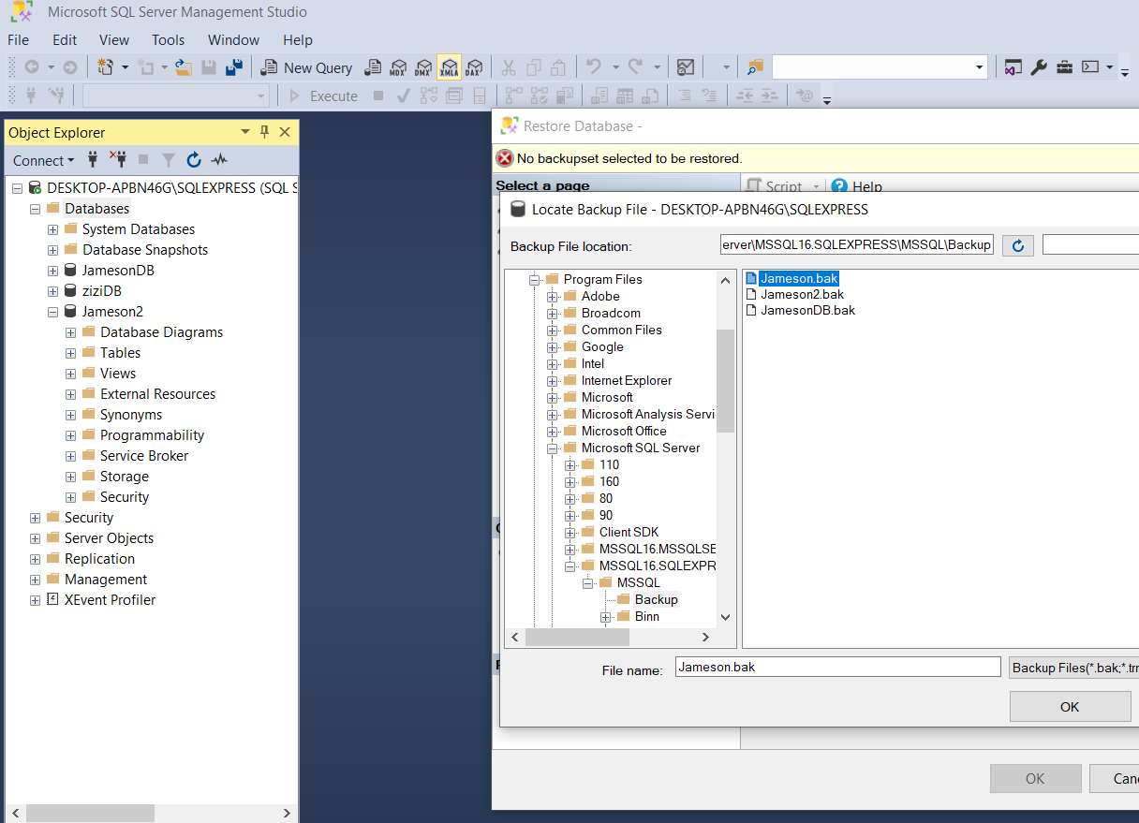

Fig 1.0 MS SQL Server – Data restoration

The .bak file was imported into the MS SQL server with using the respective instance and server name; DESKTOP-APBN46G\SQLEXPRESS and SQLEXPRESS

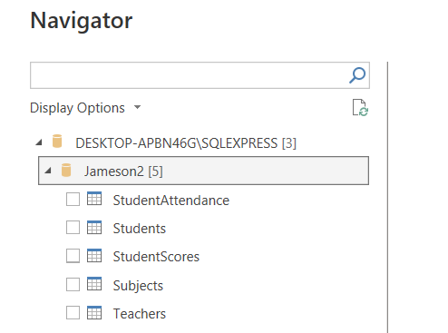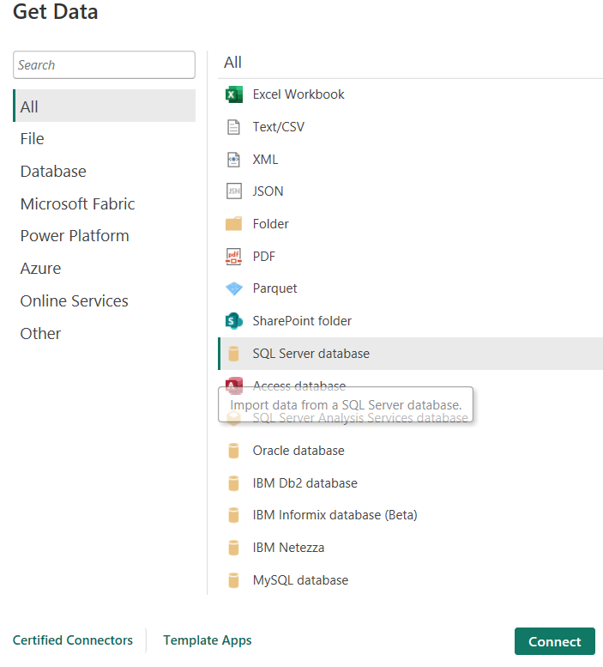

Fig 1.1 Get Data - Connecting to MS SQL Server

# Data Visualization

Please find below the link to the published PowerBi Visualization.

## [Jameson High School Academic Performance Dashboard](https://app.powerbi.com/groups/me/reports/061b0614-eb25-486f-8052-c1ab0c7f2bb8?ctid=ce0df492-7f32-43cf-b297-ee135760da1b&pbi_source=linkShare)

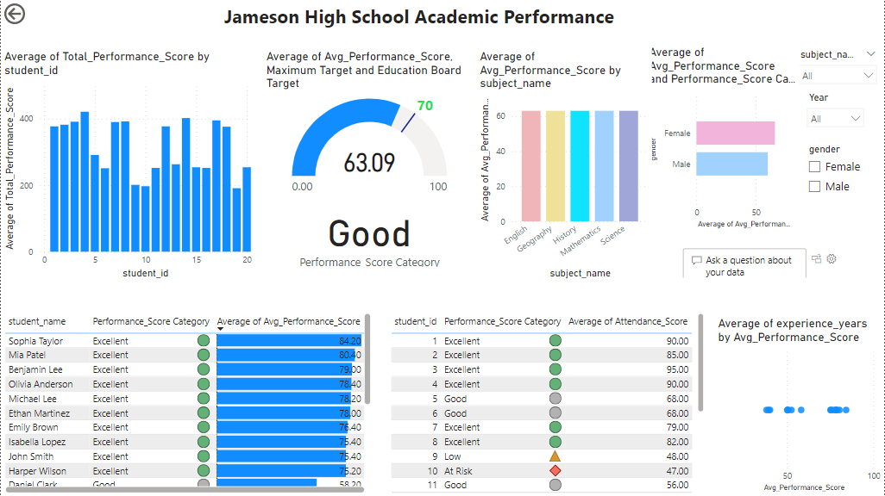

In order to investigate students performances across the given factors such as ; DOB, Gender, Subjects, Teacher’s Experience, Performance category and Performance scores, different visuals such as bar and column charts, color codes, gauge, table, slicers and scatterplot was employed t build an interactive dashboard.

## Findings

1. The overall average performance of students across subjects is 63.09, which is close to the education board benchmark, 70. At 66.08 and 60.10 respectively, both female and male students did not surpassed the education benchmark.
2. There is no correlation between average performance of the students across age and gender.
3. There is noticeable paranormal distribution in the total performance score while there is none in the average performance score against subjects.
4. About 3 students had very low performance score while over 70% performed well.
5. The students with low performance score in subjects like science also have low attendance score for respective subject.

Recommendations

Based on the analysis and findings above, the following are recommended;:

1. The school has to implement intervention targeting students with low average performance scores.
2. The school has to provide support to enable students with low performance scores improve in their subjects and attendance.
3. Work with parents to improve class attendance amongst science students and ensure that the science teachers are use effective methods in their classes.